**Practice Project 3**

**Fix Bugs**

**Sai Krishna Rajagopal**

**04-03-2022**

**GITHUB Repository URL:** [**https://github.com/SaiKrishna6699/CoreJavaTraining.git**](https://github.com/SaiKrishna6699/CoreJavaTraining.git)

**Technical Summary:**

1. **Java**
2. **Eclipse**
3. **Git**
4. **Java:**

The File Handling was developed in Java Programming Language using the concepts of File Handling, Exception Handling, Java IO

* The Application is fully functional and working perfectly with No Exceptions

Short Summary of code:

* 1. Import Arrays, Array List and Collections packages and instantiate the static main method
  2. Call to the method options Selection() is made an array List of Strings which contains the list of options for the user to select
  3. Another array of type int is created whose length is declared and all the elements int the String array are printed using a for loop
  4. Array List of type integers are stored with expenses. And a desired option from the user is got to do the specified operation using scanner class.
  5. A new Array List is instantiated and added to the expense array.
  6. The user selected option is put inside switch case and is matched with the correct case
  7. If the option does not match any of the statement default statement is printed

1. **Eclipse:**

Eclipse is the IDE used to Write the code. It is a very programmer friendly and easy to use application.

1. **Git & GitHub:**
   1. Git is the version control system used to store the data in a remote Repository.
   2. GitHub is the remote data base contains repository which is used to store the data.

Git Commands used:

$git init

$git remote add origin “[**https://github.com/SaiKrishna6699/CoreJavaTraining.git**](https://github.com/SaiKrishna6699/CoreJavaTraining.git)”

$git remote -v

$git add .

$git commit -m “First Commit”

$git branch -M main

$git add FixBugs_PP5

$git push -u origin main

1. Screenshots:

Code:

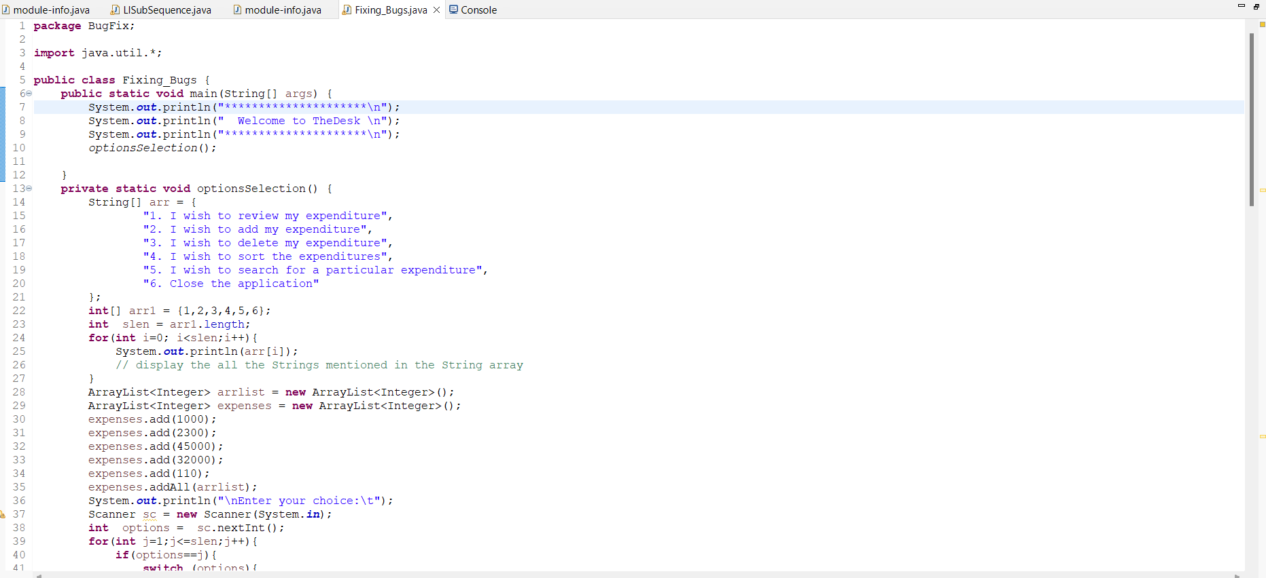

Output Sc shot:

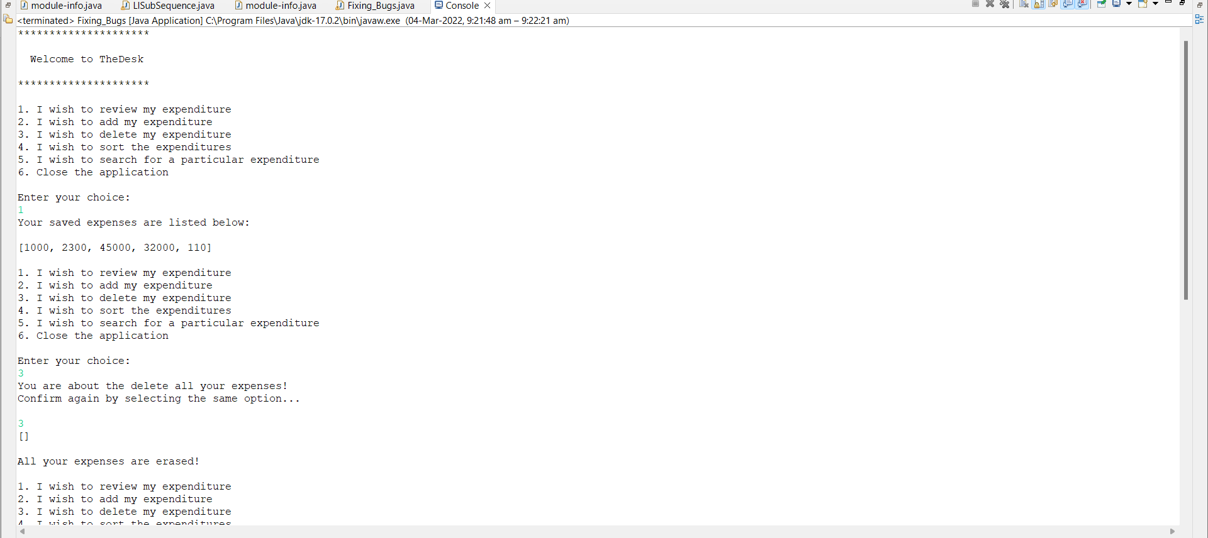

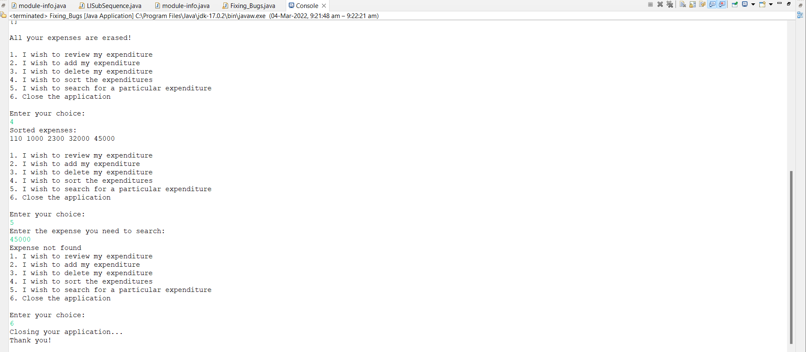

Git Commands:

